Report for the 2026 Data & Innovation for refugees and Inclusion hackathon

Promoted by UNHCR and UniTrento
Team Rocket
Aim of the hackathon:
design how that caseworker keeps saying no when the AI is wrong, and how the institution can see when they stop.

Our solution:
development and implementation of a new workflow that includes a dashboard prototype and an interaction protocol.

Steps of our work:
1)Analysis of the dataset:
The main outcome is that there is no correlation between the final score values and the final eligibility outcome (include/exclude). From this analysis, we found that there are other parameters that were assessed and recorded during the interview phase that influence the final eligibility decision.
2)Study of the currently used process
Based on the interview and the use of a scorecard to feed Cashy.
3)Theoretical implementation of the process proposed by our team.
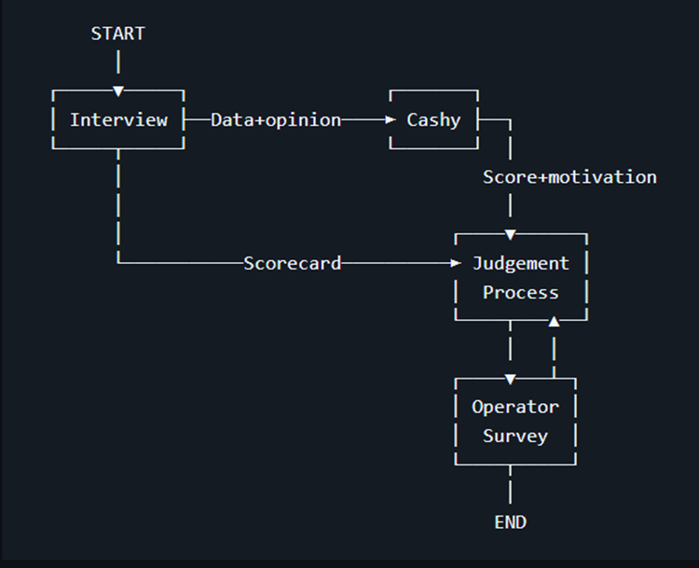
The pipeline starts with the interview. The collected data is used to fill in the scorecard. In parallel, the interviewer provides Cashy with the objective information collected during the interview, together with their subjective considerations. Cashy processes this information and produces an output consisting of two components: the result and the rational behind the result.
The scorecard output and the Cashy result are then passed to the judgment process that compares the two texts by an AI-based algorithm. Based on the outcome of this comparison, the worker’s interface is modified, potentially displaying pop-ups or warnings indicating that the operator should pay particular attention, as the reliability of the result may be low.
These warnings are also triggered randomly, rather than only when the system detects a high level of uncertainty. This is intended to prevent workers from becoming accustomed to the warnings and to reduce the risk of introducing bias into their decision-making.
If the discrepancy between the Cashy result and the scorecard result is very large (threshold to be defined), the result is hidden, and the operator is shown only the rationale behind the result.
Once the operator confirms the outcome, they are asked to complete a form to ensure that sufficient attention has been devoted to the case. At this point, the operator can also go back and review their previous steps in the workflow, for example if they realize that they may not have paid sufficient attention to the case or if they have reasonable doubts about the decision.
4)Development of Judgment Process
This step is made by a series of functions written in python. The main function is the match function, that uses an AI model to compare the percentual matching of the scorecard and the score+motivation to return a percentual value. This value is compared with a threshold value of 75% (check judgement.ipynb for more details in the implementations and the reason of the threshold value)
5. Researching of psychological papers
We researched a list of psychological papers that talk about AI and human trust in the AI work for force the human operator to don’t trust the AI model (check the bibliography)
6. The building of dashboard
We built a new dashboard that visualizes the output of Cashy and that has a series of popups to force the operator to critically think about the decision of approving or not approving the funds.
7. Making a questionaries
Starting from the questions proposed to the operator for the evaluation of Cashy we made obligatory questionnaires to force the operator to motivate their choice and force them to read in a critical way the Cashy’s output.
In particular we came up with 3 possible questions(a revision of the old one):
- Rate the effectiveness of Cashy-AI for identifying and selecting the “right” individuals for the assistance
- Why do you agree or disagree?
- Does Cashy-AI provide content that is relevant to help you make an informed decision

